December 31, 2021
Rental Group Newsletter
Snowbird update With COVID cases soaring again – this time from what appears to be a less severe strain of the virus -- we can take it as exceptionally good news to hear from Donna & Kirk that we have not had a single cancellation thus far for January – April.
Pay-per-view change Spectrum has changed how we need to go about restricting tenants from adding pay-per-view programs and upgrades. Under Brighthouse, locking out renters from ordering extras was as simple as providing a password to the cable carrier. Not so under Spectrum: We now need to set any programming limits through the parental control function of each tv’s handheld remote. Best advice until you’re in NSB again and can manually change your settings: If you notice something extra on your Spectrum bill, call the office. Send a copy of the bill, and the managers will get the tenant to reimburse you.
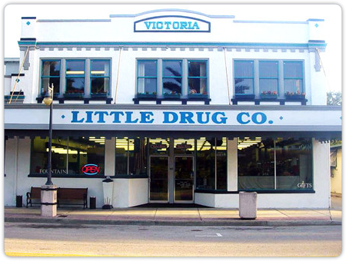
Around town Just months before its 100th anniversary, Little Drug Company, a pharmacy and soda fountain on Canal is closing its doors, a victim of the pandemic and supply chain issues. News that means the town is losing what is perhaps it’s top tourist attraction not related to the beach… a place that’s steadily earned don’t-miss status among visitors who raved about the root beer floats, the grilled cheese sandwiches, the chocolate fudge sundaes. Whenever we went there we were expecting to find our old friends Andy & Barney the next booth over. The full-service sit-down soda fountain was packed this week with people saying goodbye.
Sea-worthy North Atlantic right whale calving season is off to a bright start, with nine mother-calf pairs already spotted off the coast from Florida to South Carolina. The right whale seen here was sighted with her calf off Amelia Island by a Florida Fish and Wildlife Conservation Commission aerial survey team on Christmas Eve.

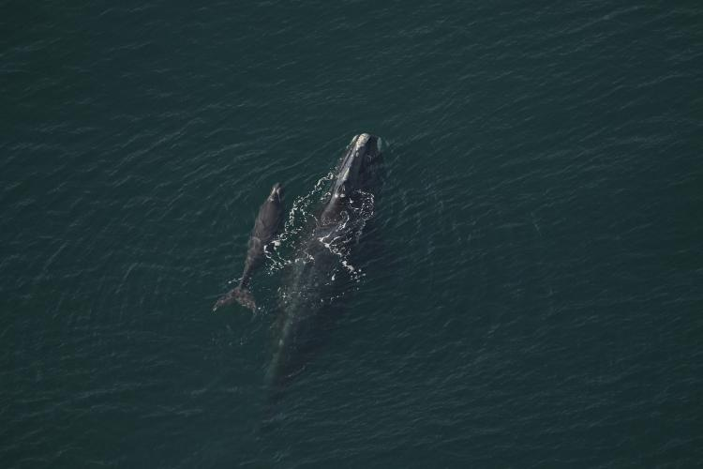
Fewer than 350 of the whales remain and the critically endangered species is currently dying at a faster rate than they can reproduce, so each birth is a cause for celebration. Only 70 reproductively-active North Atlantic right whales remain alive, researchers estimate. The southeastern U.S. is the only known area where right whale females regularly give birth and nurse their young. There are no excursions to do whale watching in Florida because sighting them is too rare, but there’s perhaps no better seat to watch out for -- December and March --than an oceanfront balcony between Jacksonville and Cape Canaveral.

Happy New Year everyone!
Bill & Sandy (#203)

