2021 Rental Group Newsletters
January 1, 2021

All-Oceanfront Vacation Rentals
Watermark Rates
--- Updated January 1, 2021 / effective for all new bookings --

WINTER (2021) January – April

2BR/2 Bath 2BR Deluxe 3BR/2 Bath

ONE MONTH | $3310 | $3410 | $3735
TWO MONTH | $6410 | $6615 | $7265
THREE MONTH | $9300 | $9610 | $10,585
FOUR MONTH | $11990 | $12,405 | $13,700
WEEKLY | $1520 | $1575 | $2165

SUMMER (2021) June thru 3rd Saturday in August

WEEKLY $1445 $1520 $2055

OFF-SEASON (2021) May & 3rd Saturday in August - December
WEEKLY $930 $1005 $1315
MONTHLY $2475 $2575 $3045

2-Bedroom / 1368 sq. feet (1226 living area + 142 balcony)
2-Bedroom Deluxe / 1570 sq. feet (1448 living area +122 balcony)
3-Bedroom / 1823 sq. feet (1573 living area + 250 balcony)
Rental information
CLEANING FEES: $100 (2-Bedroom Standard), $105 (2-Bedroom Deluxe), $120 (3-Bedroom).
TAXES: 12.5 % on all rentals of six months or less.
SHORT-TERM SECURITY / DAMAGE / DEPOSIT: $500 for all short-term reservations.
LONG-TERM WINTER RENTALS: $1000 security/damage deposit.
CANCELLATIONS: 45 days advance notice required (60 days in winter season).
PAYMENTS: Personal check, traveler's check, cashiers check, cash (Sorry, no credit cards).
CHECK IN: Between 3 & 5 p.m.; CHECK OUT: Before 10 a.m.
SMOKING: All units are non-smoking.
Rental rates & unit assignments subject to change.
Check out pictures of each vacation rental at
watermarkbeachcondo.com
Donna Maupin
Rental Manager / #103
401 N. Atlantic Avenue
New Smyrna Beach. FL 32169

386-428-3793 / watermark401@hotmail.com

Winter 2021 / January thru April

Duration | 2 Bedroom / 2 Bath | 2 Bedroom Deluxe / 2 Bath | 3 Bedroom / 2 Bath
Weekly | $1,520 | $1575 | $2,165
1 Month | $3,310 | $3,410 | $3,735
2 Months | $6410 | $6,615 | $7,265
3 Months | $9,300 | $9,610 | $10,585
4 Months | $11,990 | $12,405 | $13,700

Summer 2021 / June thru 3rd Saturday in August

Duration | 2 Bedroom / 2 Bath | 2 Bedroom Deluxe / 2 Bath | 3 Bedroom / 2 Bath
Weekly | $1445 | $1,520 | $2055

Off Season / May & 3rd Sat. in August thru December

Duration | 2 Bedroom / 2 Bath | 2 Bedroom Deluxe / 2 Bath | 3 Bedroom / 2 Bath
Weekly | $930 | $1005 | $1,315
Monthly | $2,475 | $2,575 | $3045

March 15, 2021
Rental Group Newsletter
Summer outlook
This week is the first anniversary of when most of us heard about the global pandemic, and were advised to stay in, space out, lay low, mask up, order out, stop shaking hands and start washing them. We stocked up on Lysol, Clorox Wipes, Purell and toilet paper if we could find them. The phones at the Watermark started ringing and ringing with people canceling vacations. Over the past year we changed the way we live, and most of those changes – like the Plexiglas partition in the manager’s office -- are still part of the daily routine. The COVID virus has claimed more than 2 million lives worldwide. It is still with us, and it has now sprouted variants. But we know a lot more about this enemy than we did at the start, and now have an arsenal of effective vaccines that we didn’t have a year ago. Finally, this world war seems winnable. The phones are still ringing again at the Watermark, but this time they’re different. “One day around the first of the month, we took eight reservations in one day!” Donna told us.
- April is sold out.
- May is completely booked.
- June is filling in nicely.
- July is mostly full, with a handful of openings in the latter part of the month.
- As far out as the first week of August (7/31-8/7) only 3 units are currently un-booked.

Website enhancements
The redesigned website turns 4 this month. We’re working with Shea & Elisa over at Hosting NSB on freshening up the welcome-page slide show. Check it out.
Snowbird status
Our winter renters have settled in -- a friendly bunch, relieved and grateful to be in Florida… swapping strategies on how and where to get COVID vaccines. To that end, they’re getting with some assistance from Donna and Kirk with the paperwork they need to verify short-term residency.
Beach driving

Mark Lane, columnist for the Daytona Beach News Journal has been covering the beach driving issue since the Model T. His take on the controversy heating up again: “Without beach driving, large stretches would be inaccessible to locals or tourists. But opening to driving everywhere would mean tearing up painstakingly negotiated agreements with the U.S. Fish and Wildlife Service that limit driving to protect sea turtles and other wildlife. Meanwhile, sea-level rise and beach erosion are steadily at work closing big swaths of beach to cars regardless of anything the county decides. Nature favors a long-range traffic phase-out. Fortunately, this is a big beach — 47 miles [in Volusia County] — with room for driving in some places and traffic-free stretches in others. The current compromise is an uneasy one but accommodates all beachgoers. And it will remain that way even though the argument is once more getting heated.”

Where lives pass, memories carry on forever.
It was with much sadness that we learned of the passing of Jim Weeks (#401) and Beverly Fleming (#201), two longtime owners whose good natures helped make the Watermark community such a special place over the years. Our hearts go out to Sue and the Weeks family, and to the Flemings and Boones on their loss. Here are the links to the obituaries:
JAMES WEEKS Obituary (2021) - Lakeland, Fl, FL - The Ledger (legacy.com)
Beverly Fleming Obituary (2021) - Orlando, FL - Orlando Sentinel (legacy.com)

Bill & Sandy (#203)
--------------------------------------------------------------------
April 1, 2021

Rental Group Newsletter

10 little things that make a big difference in building return renters

Spring has sprung, and it's a good time to remind everyone of some of the “little things” we innkeeper-owners should be routinely addressing even if we haven’t gotten around to more expensive upgrades. We asked D & K for their Top 10:

- Replace any bed pillows that have gone flat or are stained.
- Keep bed linens fresh. [If you’ve had the same sheets for 4-5 years, it is way, way past time to replace them.]
- Replace faded or pilled throw rugs, or any with backs that are disintegrating.
- Update the comforter/quilt set on each bed every couple of years.
- Make sure you always have matching towels, not just a hodge-podge.
- Inspect your small appliances and kitchenware regularly. [If the coffee pot is stained [the carafe or the base plate) replace if doesn’t look clean anymore.]
- Check stove drip pans if you have them and replace so we don't have to put aluminum foil over them. Also, check stove rings, dishes, glasses, and have one nice matching set of silverware. [You can have others for extras].
- Replace outdated lamps… and check the lampshades, too, to be sure they’re not stained or coming apart.
- Replace outdated appliances and TVs.
- Keep your window coverings in good working order -- and check for cleanliness. [Some of the blackout drapes are dirty on the backside or water-stained. The verticals in some units are stained or dingy-looking.]
Taxes
With the tax season extended to May 17, we call your attention to IRS Publication 527 on vacation rentals – detailing current tax code on deductible expenses, depreciation and rules when there is also personal use of the unit. Here’s the link:
Publication 527 (2020), Residential Rental Property | Internal Revenue Service (irs.gov)

Sea-worthy

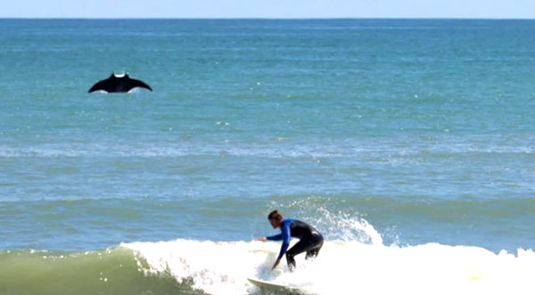

Talk about the stunning views we get along this part of the Atlantic coast – from sunrises to night launches and, in between, how we’re entertained by kite surfers, porpoises, sharks, dive-bombing pelicans and an occasional breaching whale. But manta rays? They’ve been spotted in droves just one county over (Brevard) where this unassuming surfer was photographed a few week ago. Rusty Escandell was taking photos of surfers when he captured this image. With a wingspan of up to 29 feet, the giant manta ray has the distinction of being the world's largest ray. This one appears to be a juvenile, roughly half that size. Although manta rays are in the shark family, they don’t have large teeth like sharks and aren’t considered a threat to humans. Over the past year, there have been similar sightings in the waters of South Florida.
Happy Easter everyone!
Bill & Sandy (#203)

------------------------------------------------------------------------------

Rental Group Newsletter
June 11, 2021
Winter ’22 sold out All Watermark rental units for next winter have been spoken for. This says a lot about the bond we’ve have established with our snowbirds, about the priority they give their annual pilgrimage and about the job D&K did this spring at renewal time.
Summer ’21 surging Donna tells us we’re 95% booked for summer, too. Of the 190 rental weeks available this season, 180 had been reserved by Memorial Day. NSB tourism overall appears to be coming back strong, well ahead of a year ago, according to city officials.

Hurricane Season Three units got coastal-grade sliders installed just ahead of hurricane season, bringing to 23 of 36 the total units with upgraded sliders. The sturdy look and feel of our Velocity-brand replacements will give Sandy & me peace of mind whenever a hurricane directly threatens the Watermark. Built to keep water out and drain it outside, this newer style slider will put an end to any need to line the tracks with rags prior to a hurricane. The only concern we’ve had thus far is with stepping over the 3½-inch threshold. It takes some practice – more for some than others -- so we’ve left a heads-up note for our renters.

Details, details We’ll be reviewing rates this fall but, meanwhile, we can’t stress enough how closely related is the job we do in keeping up with renter expectations. To that point:

- Donna says some throw rugs are looking dingy. [When replacing, get washable ones.]
- Some bedskirts are the same as they were when D&K started here five years ago. [If yours are frayed, stained or badly faded, replace as soon as you can.]
- Looks like the dirty walkway dilemma will be with us through peak summer rental season when heavier foot traffic will no doubt make the appearance even worse. For now, it’s most conspicuous at unit doorways on floors 2-6, at the elevator and steps of lower floor stairwells. Bill Biedenbach tells us the walkways are deep cleaned every couple of months and that those will continue, and reassures us the board is on the case.
- As always, we encourage owners who’ve made renovations to update their website pics accordingly It’s also an ideal time to remind those who haven’t done so recently to review and update as needed the website text describing your rental unit’s amenities. Photo shoots any content revisions can be arranged through the office.
Word’s out NSB, once among Florida best-kept secrets, has been getting some national pub: HGTV’s Top 20 beaches in Florida… Southern Living’s Salty Mermaid (as one of the favorite stays in the south) and Chicago Trib’s “Cutest beach towns in Florida.”
Around town The closest restaurant to the Watermark is eyeing a mid-to-late-June return after an unexpected kitchen fire this spring. Here is the link to a Hometown News article about how some patrons raised more than $20,000 in an effort to help the Beacon shine again:

tps://www.hometownnewsvolusia.com/news/customers-try-to-save-new-smyrna-beachside-eatery/a rticle_233da6e4-bcbf-11eb-b4c3-ef15d5c4b9c1.html

We invited our newest members to introduce themselves

We are Harold and Lisa Anness and reside in Cincinnati, Ohio. We were fortunate to close on Unit 604 on February 19, 2021 after working on the deal for almost a year. We originally purchased a unit at Holiday Cove North in 2006. Harold retired as a real estate attorney in 2018 and we started spending more time in New Smyrna Beach.

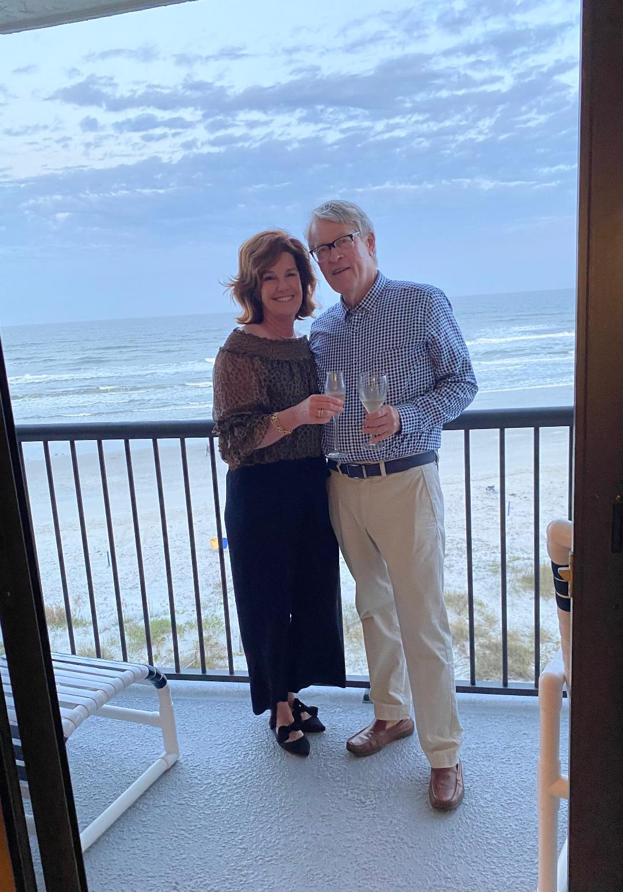

We soon realized that more space was needed which put the Watermark in play. Lisa is an international Delta flight attendant based in New York. Lisa took a 13-month time-out because of COVID-19 but started back to work on May 1st with a trip to Tel Aviv. We spent last winter at the Watermark in Unit 603. Hopefully our renovation of Unit 604 will start shortly after Labor Day and be completed by year’s end. We intend to spend the winter in New Smyrna Beach. We look forward to meeting everyone.
Bill & Sandy
#203
-------------------------------------------------------------
August 5, 2021
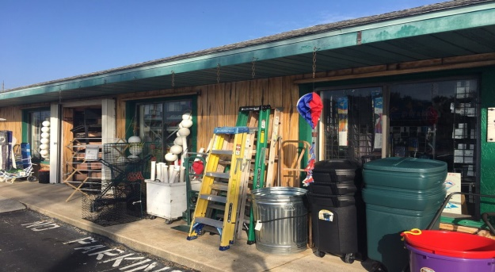
Rental Group Newsletter
Venerable beachside hardware store is closing
Some got keys made there…others found their odd-size a/c filters; their beach carts, funky kites, metal detectors, tide clocks and frozen bait. For four decades, Coronado Hardware, just a mile south of the Watermark, has been a lifesaver to beachside residents as the closest source for all variety of whatsits, thingamajigs and doohickeys. We sorely miss this small place already, just hearing it will close soon following the owner’s retirement. We wish all those folks well.
Back in business? Volusia’s bed tax collections were up 517% in April from the paltry level a year ago… and up 121% from May 2020. At the Watermark, Donna reports September & October bookings are looking “pretty full” but notes that she got a few cancellations last week due to Florida’s high COVID numbers.
Red Tide blues A growing algae bloom on the state’s west coast once again is threatening summer tourism along several of Florida’s premier beaches. In Pinellas County alone (St. Pete, Clearwater.), three million pounds of dead fish were removed last week. Last time it got that bad (2018), many vacationers scrambled to find lodging along the state’s East Coast where Red Tide is less frequent. Since the early 1950s, the Red Tide has struck the Gulf coast nearly 60 times, and the Atlantic coast only nine.

Preventative maintenance With our a/c condensers up on the roof, the beating they take from the harsh coastal elements is out of sight, and often out of mind. That’s why an annual lookover is prudent. Owners once had an opportunity to have this done at the same time by the folks that service all but one of the Watermark’s a/c’s (Advanced Air, 386-675-1158) at a minimal cost per owner. The group aspect of that deal is no longer offered but the rest of service is, the same 18-point visual check for same low cost ($18.95). A more thorough 66-point service call runs $79.

Leland Warmoth The Watermark lost another old friend with the passing of Leland Warmoth, husband of former rental agent Joan. As Joan’s right-hand man, he helped owners and renters with their fix-it needs. A proud Navy vet, he was the longtime GM of a Volkswagen dealership in Illinois before coming to NSB to be near his grandchildren (now numbering 11). An avid boater and golfer with three holes-in-one to his credit, he loved being near the coast. He lived his life with his favorite motto in mind: “You have to make your fun; it doesn’t just happen.” He was 89.

Sea-worthy

South Carolina State Parks
This two-headed baby sea turtle was one of five hatchlings discovered in a nest found on a South Carolina beach, at Edisto State Park, last week. A group of turtle nest patrollers were making a routine check when they stumbled across the rare loggerhead. Nesting season runs May through October.
Bill & Sandy
(#203)

--------------------------------------------------
Here is a new rate survey showing how our 2 BR units stack up with a cross-section of the competition -- bigger/smaller complexes, newer/older, drive side/car-free, plus a few others that are especially close to Flagler Avenue. We last raised our rates 2 years ago, and it's time to consider another round of adjustments. Feel free to share your suggestions. Stay well. -- Bill & Sandy

September 23, 2021
Rental Group Newsletter
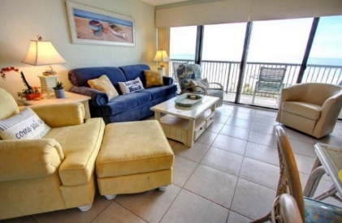
Rate Survey
This is one in a series of rate checks for the Watermark Rental Group members to measure how our rates compare with our competitors along NSB. Listings are in descending order by winter monthly rate.
Winter/mo Summer/wk Holiday/wk Off-season
Errol by the Sea 5400-6400 1600-1800 extra 1400
1250 sq ft -- No-car beach; rec room; 2 pools + kiddie pools, lighted tennis court; shuffleboard; basketball, pickleball (equipment available in the office); child-friendly; some pet-friendly units; not available for large parties; winter social program; boats by reservation; lock-out fees; accepts all credit cards online; charges substantial holiday premium; built 1973.

Ebb Tide 5000 2500 extra 1400
1550 sq ft – No-car beach; 8-story, 53-unit complex w. 3/3 and 2/2 oceanfront rentals; most spacious units of those surveyed; clubhouse, fitness room, hot tub, sauna, tennis; each unit has (1) parking space/ assigned garage; pet-friendly, no credit cards; charges substantial premium for 8 holiday weeks including Race Weeks; built 1986.

Sandpiper 4200-5000 2000-2500 extra 1600/2000
1300 sq ft – No-car beach, clubhouse w. pool tables; 2 pools plus kiddie pool, putting green, shuffleboard; communal laundromat on various floors; deluxe units priced individually; accepts Mastercard, Visa & Discover; charges holiday premium; offers travel insurance; 7th floor clubroom (owners only); built 1998.

Moontide 4590 1480-1845 extra 1105
1360 sq ft – No-car beach, gated garage; rooftop pool; nighttime security; surveillance camera; accepts credit cards. A 3% discount to those who pay personal or travelers' checks, cash, or money orders; substantial holiday premium; No security deposit; charges non-refundable ‘Damage fee’ for which renters are protected for accidental damage up to $1,000; built 1983.

The Inlet at Minorca 4250 1600 extra 1250
1400 sq ft, -- No-car beach; access to resort amenities of gated, well-maintained Minorca, workout room, inside washer-dryers. 24-hour security; 4 clay tennis courts; Next door is Smyrna Dunes State Park with its stunning beach & nature walkways; Visa, MasterCard, Discover; charges holiday premium; no hurricane refunds, Trip Insurance… built 1986.
Coronado Towers 4000-4200 1350- 1450 extra 1150-1250
1164-1270 sq ft – driving beach, walking distance to Flagler Ave, no blocked or partially blocked ocean views, in-unit washer/dryers, no-smoking, no pets, free WIFI, satellite TV, sauna, 1 barbecue grill, reserved parking, on-site manager. Rental rates set by unit owner; summer rate includes May; built 1972.

WinSan 4200 2100 no 1330-1400
1010 sq ft – Driving beach; our neighbor just south of us and the only condo surveyed closer to Flagler Ave (1 block) ; Win-San is comprised of about 2/2 condominiums in flat and townhome-style layouts. Its 40 rentals managed by 2 local agencies; surprisingly, its significantly smaller units are priced higher than ours. ($4200 vs $3310); built 1973.

Sunrise 3975 1500 no 1750
1384 sq ft – No-car beach, all-oceanfront, tennis, shuffleboard & basketball, washer & dryer on each floor, enclosed, enclosed 2-level parking garage; some pet-friendly units; no credit cards; no apparent holiday premiums; $250/night w. 4-night minimum in off-season; built 1981.

Colony Beach Club 3400/4000 1445 extra 975
900-1000 sq ft -- No-car beach, cottage-like complex w. 100 1 & 2-BR rentals; smallest surveyed in square footage; 2 large pools, community laundry, covered parking; credit cards; undergoing a staircase replacement project; also, a rates transition after in-house rental office shut down; 60% signed up with a rental service allowing them to quote own rates; built 1973.

Golden Arms 3400 1300-1600 extra 1250-1500
1200 sq ft.-- Driving beach and our nearest competitor included in this survey; short walk to Flagler Ave (they call it a 2-block walk, but we know better); keyless entry, shuffleboard, parking garage, game room, putting green; charges modest holiday premium; appears to have given owners latitude in setting their own rental rates; built 1974.

Watermark 3310-3410 1445-1520 no 930/1005
1250-1475 sq ft -- Driving beach, all-oceanfront w panoramic ocean views; large covered balconies; 24 large rental units, more dependable, unit-dedicated WiFi; in-unit washer-dryers; secure one-car garages, offers 2 sizes of 2BRs, one with abt 200 sq ft more space; 2-block walk to Flagler Ave; no credit cards, no extra for holidays; hurricane refunds; built 1980.

The Pelican 3276 1348 extra 1127
1192 sq ft -- Driving beach; 2 pools, clubhouse, shuffleboard, grills, pet-friendly. In the final stages of a major renovation that began in 2019, warning renters to expect noise; promoting itself with this slogan: “Prestige without pretense,” website also emphasizing “when you return we don’t simply welcome you back, we welcome you back home!” Built 1974.

Hacienda del Soil II 3062 979 extra 870
1076 sq. ft – No-car beach, older, well-maintained condo with some limited-view units; clubhouse; shuffleboard; some rentals have pay WiFi and in others owners have supplied more secure, dependable Wi-Fi; some have in-unit washer/dryer; charges holiday premium; website currently promoting its friendly, laid-back staff; built 1973.

Seascape Towers 3000 1300-1500 no 1500
1221 sq ft, -- No-car beach, all-oceanfront rentals, “family oriented,” in-unit washer-dryer, lighted tennis, men’s & women’s saunas, spa in pool area; gated underground parking; oceanside and indoor shuffleboard; no pets; currently offering a ’Best Weather’ monthly rate Sept-May instead of traditional off-season rate, no apparent holiday premiums; built 1988.
Shoreham-by-the-Sea 2900 1350 extra 1000
1200 sq ft -- No-car beach, club room, most of the 58 units offer ocean views; in-unit washer/dryer, manicured grounds, no tennis; motorcycle and boat trailer parking; canoe and kayak racks; charges substantial holiday premium; currently promoting itself with this line: “Fondly known as the Friendliest Complex in New Smyrna Beach;” built 1978.

Noteworthy in this year’s update

Winter rates
- Winter rates ranged from $2900/mo. to $6400/mo. with a median of $3990/mo.
- Watermark winter rates ($3210-3410) rank 11th of 15 [$500+ under survey median]
Summer rates
- Summer rate range from $979/wk. to $3000/wk. with a median of $1640/wk.
- Watermark summer rates ($1445-1520) rank tied for 7th of 15) [$100+ under survey median]
- Rate nearest ours: Colony Beach Club @ $1445
Off-season rates
- Off-season rate range: $870/wk to $2000/wk with a median of $1175/wk
- Watermark off-season rates ($930-1005) rank 14th of 15 [$150+ under survey median]
- Rate nearest ours: Colony Beach Club @ $975.
Nearest to us
- In winter rate: Sunrise @ $3300
- In summer rate: Colony Beach Club @ $1445
- In off-season rate: Colony Beach Club @ $975
- In age (41 years): Sunrise (40 years)
- In square footage: Errol by the Sea
- In physical distance: WinSan
- In walking distance to Flagler Ave: WinSan
Significant rate adjustments since last survey (2019)
- Sandpiper raised its monthly winter rates $1200/mo. since 2019
- Sunrise lowered some monthly winter rates by $150/mo. since 2019
Trends
- A majority (12 of 15) passed the $1000/wk. threshold in off-season rates. [Our 2 BR hasn’t, but would likely with the next increase]
- A majority (11 of 15) charge extra for holiday stays. [Watermark hasn’t for years].
- The condos surveyed appear to be more closely split on the use of credit cards [Watermark does not accept any due to the extra expense associated with them].

Watermark’s current marketing niche

- Nice, clean, well-equipped all-oceanfront rentals on the driving side of the beach
- Short walk to festive Flagler Ave.
- Among the smaller vacation condo rentals in terms of available rentals.
- Among the more spacious units in terms of square footage
- Among the few NSB condominiums that don’t raise rates on holidays.

- Good value
Managers’ assessment
- We both feel that the rates should go up in all categories but we feel that each season should be addressed individually as opposed to across the board.
- We hear from tenants and prospective tenants daily in the office, on the phone and via email. They share their experiences with other condos and why they have left those buildings. We want to be sure that we are being fair and the increase is justified.
- From previous meetings, we have all agreed that it is better to increase a smaller amount regularly than to increase a large amount every so often.-- D&K
----------------------------------------------------------------------------------------

October 19, 2021

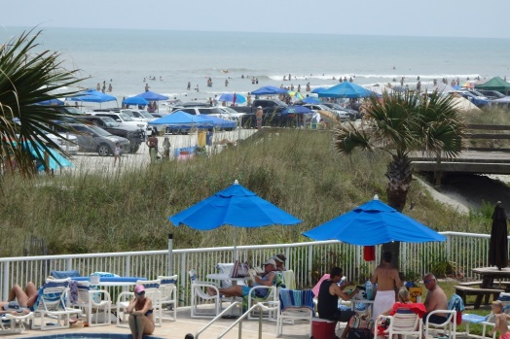
Rental Group Newsletter

The Watermark Rental Group voted Saturday to raise winter rates by 6%, in summers by 7% and in the off-season by 5%.

Ten of 24 owners who rent out their units participated in this year’s rate review, overwhelmingly approving the rental managers guidance that took into consideration such key pricing factors as

• -- ---our rate history
• ---- the findings of our recent rate survey
• --- what tenants are saying
• --- raising rates w/o jeopardizing owner income
• --- our remarkable occupancy rate over the first 9 months of the current year (89%)
• --- our volume of repeat customers (70-80%)
• --- how well we as a group have kept our places in good repair, updated and appealing

The new rates are effective with all new bookings, and will appear on the website this week.

Raising rates is especially challenging for smaller rental condos mainly because the vast majority lack the deep budgets necessary to maintain resort-tier amenities. Smaller doesn’t automatically equate to charging less, however, trying to compete with bona fide resorts does presume the smaller player has taken extraordinary pride in maintaining the fewer amenities it does have.

The attached spreadsheet provides members with all the details, including amounts of each increase by unit size

 |  |  |  |  |  | RATE SHEET
WINTER
2 BEDROOM | CURRENT |  |  |  |  |  |  |  | TOTAL
MONTHS | RATE | INCR | INCR% | BASE RATE | CLEANING | SUB TOTAL | TAX (12.5%) | TOTAL | INCR
1 | $3,310.00 | $200.00 | 6 | $ 3,510.00 | $ 100.00 | $ 3,610.00 | $451.25 | $ 4,061.25 | $225.00
2 | $6,410.00 |  | 6 | $ 6,810.00 | $ 100.00 | $ 6,910.00 | $863.75 | $ 7,773.75
3 | $9,300.00 |  | 6 | $ 9,900.00 | $ 100.00 | $ 10,000.00 | $1,250.00 | $ 11,250.00
4 | $11,990.00 |  | 6 | $ 12,780.00 | $ 100.00 | $ 12,880.00 | $1,610.00 | $ 14,490.00
Weekly | $1,520.00 | $95.00 | 6 | $ 1,615.00 | $ 100.00 | $ 1,715.00 | $214.38 | $ 1,929.38 | $106.88
2 BEDROOM DLX
1 | $3,410.00 | $205.00 | 6 | $ 3,615.00 | $ 105.00 | $ 3,720.00 | $465.00 | $ 4,185.00 | $230.62
2 | $6,615.00 |  | 6 | $ 7,015.00 | $ 105.00 | $ 7,120.00 | $890.00 | $ 8,010.00
3 | $9,610.00 |  | 6 | $ 10,195.00 | $ 105.00 | $ 10,300.00 | $1,287.50 | $ 11,587.50
4 | $12,405.00 |  | 6 | $ 13,160.00 | $ 105.00 | $ 13,265.00 | $1,658.13 | $ 14,923.13
WEEKLY | $1,575.00 | $95.00 | 6 | $ 1,670.00 | $ 105.00 | $ 1,775.00 | $221.88 | $ 1,996.88 | $106.88
3 BEDROOM
1 | $3,735.00 | $225.00 | 6 | $ 3,960.00 | $ 120.00 | $ 4,080.00 | $510.00 | $ 4,590.00 | $253.12
2 | $7,265.00 |  | 6 | $ 7,685.00 | $ 120.00 | $ 7,805.00 | $975.63 | $ 8,780.63
3 | $10,585.00 |  | 6 | $ 11,170.00 | $ 120.00 | $ 11,290.00 | $1,411.25 | $ 12,701.25
4 | $13,700.00 |  | 6 | $ 14,415.00 | $ 120.00 | $ 14,535.00 | $1,816.88 | $ 16,351.88
WEEKLY | $2,165.00 | $130.00 | 6 | $ 2,295.00 | $ 120.00 | $ 2,415.00 | $301.88 | $ 2,716.88 | $146.25
SUMMER
WEEKLY
2 BEDROOM | $1,445.00 | $105.00 | 7 | $ 1,550.00 | $ 100.00 | $ 1,650.00 | $206.25 | $ 1,856.25 | $118.12
2 BED DLX | $1,520.00 | $110.00 | 7 | $ 1,630.00 | $ 105.00 | $ 1,735.00 | $216.88 | $ 1,951.88 | $126.87
3 BEDROOM | $2,055.00 | $145.00 | 7 | $ 2,200.00 | $ 120.00 | $ 2,320.00 | $290.00 | $ 2,610.00 | $163.12
OFF SEASON
WEEKLY
2 BEDROOM | $930.00 | $65.00 | 7 | $ 995.00 | $ 100.00 | $ 1,095.00 | $136.88 | $ 1,231.88 | $73.13
2 BED DLX | $1,005.00 | $70.00 | 7 | $ 1,075.00 | $ 105.00 | $ 1,180.00 | $147.50 | $ 1,327.50 | $78.75
3 BEDROOM | $1,315.00 | $95.00 | 7 | $ 1,410.00 | $ 120.00 | $ 1,530.00 | $191.25 | $ 1,721.25 | $106.87
MONTHLY
2 BEDROOM | $2,475.00 | $125.00 | 5 | $ 2,600.00 | $ 100.00 | $ 2,700.00 | $337.50 | $ 3,037.50 | $140.62
2 BED DLX | $2,575.00 | $130.00 | 5 | $ 2,705.00 | $ 105.00 | $ 2,810.00 | $351.25 | $ 3,161.25 | $146.25
3 BEDROOM | $3,045.00 | $155.00 | 5 | $ 3,200.00 | $ 120.00 | $ 3,320.00 | $415.00 | $ 3,735.00 | $174.37

-----------------------------------------------------------------------------------------------------------

December 31, 2021

Rental Group Newsletter
Snowbird update With COVID cases soaring again – this time from what appears to be a less severe strain of the virus -- we can take it as exceptionally good news to hear from Donna & Kirk that we have not had a single cancellation thus far for January – April.
Pay-per-view change Spectrum has changed how we need to go about restricting tenants from adding pay-per-view programs and upgrades. Under Brighthouse, locking out renters from ordering extras was as simple as providing a password to the cable carrier. Not so under Spectrum: We now need to set any programming limits through the parental control setting of each tv’s handheld remote. Best advice until you’re in NSB again and can manually change your settings: If you notice something extra on your Spectrum bill, call the office. Send a copy of the bill, and the managers will get the tenant to reimburse you.
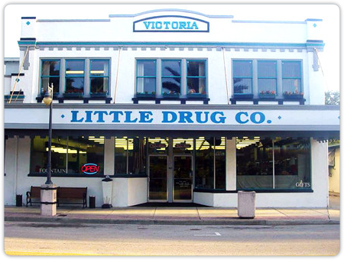
Around town Just months before its 100th anniversary, Little Drug Company, a pharmacy and soda fountain on Canal is closing its doors, a victim of the pandemic and supply chain issues. News that means the town is losing what is perhaps it’s top tourist attraction not related to the beach… a place that’s steadily earned don’t-miss status among visitors who raved about the root beer floats, the grilled cheese sandwiches, the chocolate fudge sundaes. Whenever we went there we were expecting to find our old friends Andy & Barney the next booth over. The full-service sit-down soda fountain was packed this week with people saying goodbye.
Sea-worthy North Atlantic right whale calving season is off to a bright start, with nine mother-calf pairs already spotted off the coast from Florida to South Carolina. The right whale seen here was sighted with her calf off Amelia Island by a Florida Fish and Wildlife Conservation Commission aerial survey team on Christmas Eve.

Fewer than 350 of the whales remain and the critically endangered species is currently dying at a faster rate than they can reproduce, so each birth is a cause for celebration. Only 70 reproductively-active North Atlantic right whales remain alive, researchers estimate. The southeastern U.S. is the only known area where right whale females regularly give birth and nurse their young. There are no excursions to do whale watching in Florida because sighting them is too rare, but there’s perhaps no better seat to watch out for -- December and March --than an oceanfront balcony between Jacksonville and Cape Canaveral.
Happy New Year everyone!
Bill & Sandy (#203)

