February 28, 2017

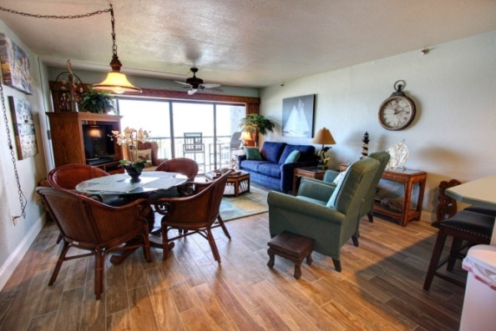

Renters Group Newsletter

Redesigned website goes live

The redesigned Watermark website is now live online… The name is the same – watermarkbeachcondo.com – but the look, feel and content options have all been enhanced to benefit Watermark owners, Rental Group members and prospective renters. A few of the highlights:

- For the first time, prospective renters will be able to check out and compare the Watermark’s 22 rental accommodations online before calling the office to book.
- The pluses of the Watermark as a vacation destination are given much more visibility -- spelled out in three categories: Our Rentals, Our Grounds and Our Location and a redesigned Area Links page on which users can check NSB weather, surfing conditions and special events.
- In a new area called Raves, you can see what a memory-making place the Watermark has been for past tenants – in their own words.
- In an all-new owners-only area, you will be able to stay up with Watermark news… ask the board a question… and make a suggestion in the Maintenance Suggestion Box.
- A new Watermark Owner Calendar can help remind you of upcoming meetings, deadlines and special events.
- Owners will also be able to use the website as a resource for finding a repair person familiar with the Watermark.
- Hurricane preparedness tips specific to the Watermark are laid out in sequence – from what you should be concerning yourself with well before Hurricane Season, through specific hurricane warnings and evacuation orders, and immediately after a hurricane.
- On the topic of finance, you can find the annual operating budget, recent condo sales, assessment notices, and a complete assessment history of the Watermark going back to the very first in the 1980s.
- In the Archives area, you’ll be able to access key condo docs -- from the Watermark’s official founding charter and bylaws to Watermark Architectural Standards, Florida Condo Statutes and the IRS guide to Ownership of Residential Rental Property & Vacation Homes.
- Access to the Owners section requires a user ID and password:
- The ID is marker401
- The password is loggerhead
  - The site was designed by Hosting/NSB. There are rather simple websites… and then there are more complex ones such as ours – with lots of pieces and parts, nuances in language, photo selection and marketing considerations. Shea and Elisa Crawford brought a rare combination of mindfulness, creativity, efficiency and patience to our redesign project -- fantastic collaborators every step of the way.
- To give credit where credit is also due, it should be noted that this new site was a real community effort. Organizing the hundreds of interior photos to be shot within an especially timeframe took the full cooperation of Rental Group members to make happen. Doug Howe contributed the Assessment History chart. Leave it to Doug to come up with those. Other ideas date back to our very first brainstorm session with Norm Himes. And, of course, our fearless leaders on the Watermark board have been supportive from the get-go.
- We hope you like it.
- As much as we’ve tried to get everything just right, gremlins could well have been missed, so please let us know right away of any inaccurate or out of place information.
- We’ll be adding features and updating content as we move forward. So we welcome your feedback – especially ideas for features you’d like to see introduced.

Bill Dunn, Donna Maupin & Tom Wall

[Website redesign team]

March 11, 2017

Rental Group Newsletter

Important document has been mailed to you

Watch for a letter from Donna Maupin in the next few days. Your signature on this legal doc is necessary to ensure the orderly transfer of the processing aspects of Watermark rentals from Beachside Realty to Donna. On March 15, she and Kirk assume all Watermark rental responsibilities, including accounting, collections, banking and payments that were handled for the past year by Beachside. This legal form authorizes Donna to be our rental agent with added financial responsibilities. Please sign and return promptly…and join us in congratulating Donna on completing the major hoop-jumping needed over the past year to get her license.
New website already gets results

The feedback since the launch of the website 10 days ago has been very positive… and we know from Donna that the site is getting results. Shea Crawford of Hosting.NSB is currently troubleshooting one of the few issues – one involving pictures not showing, and pictures appearing for a moment but disappearing. This seems to involve older cell phones that just can't handle the high picture quantity & quality. Shea is confident the issue can be resolved in the next few days.

Members should consider the new website as one big advertisement for our vacation rentals. But as inviting as that advertising message is, it currently lacks a widespread audience beyond the Watermark family and those who come across it on the New Smyrna Beach Visitors Bureau website. We’ve got a wonderful product to promote, but it won’t promote itself. The more folks who know about the new site, the more pass-along traffic it will generate… This is an ideal time to pass the word about watermarkbeachcondo.com because many families are still actively planning summer vacations.

Bill & Sandy
#203
March 18, 2017
Rental Group Newsletter
We’ve had 5 bookings from the redesigned website since its launch 18 days ago… and a request every day for the last 4 days.
We’ve made some adjustments that should fix that problem a few of you were having on older cell phones seeing the website’s photos.
Reminder to tell all your friends/family to visit the web site to help our ratings and boost our search position. The more folks who know about the new site and go there, the more pass-along traffic it will generate. This is an ideal time to pass the word about watermarkbeachcondo.com because many families are still actively planning summer vacations… and we do have summer openings to fill.
We are regularly adding to the site, so please get in the habit of checking it from time to time.
Reminder – Cleaning fees are going up $10 effective next week (on 3/25/17). These increases were approved at the rental meeting in October and for a while you’ll see the extra $10 coming out of your rental proceeds… until the increases cycle through all the existing reservations that were in place prior to the raise being approved.

Bill & Sandy
(#203)

