January 10, 2020

Rental Group Newsletter
Snowbirds are back to NSB; and many have landed at the Watermark
The snowbirds are flocking into Florida and, boy, do they love New Smyrna Beach. They come in all shapes, sizes, accents and plumages. The Watermark’s this winter hail from 19 distinct addresses – Canada, Connecticut, Georgia, Illinois, Indiana, Iowa, Kentucky, Maine, Massachusetts, Michigan, Minnesota, Missouri, Nebraska, New Jersey, New York, Ohio, Rhode Island, Virginia and Wisconsin. Many are the same folks who’ve been coming back year after year in their time-honored ritual of escaping the bitter cold elsewhere.

On days when we’re wearing sweatshirts they are the ones walking Flagler or playing shuffleboard in Bermuda shorts and t-shirts that say things like, “I’m from Ohio: What’s Your Excuse?” and “RETIRED PERSON: THIS IS AS DRESSED UP AS I GET” I spotted one sitting at the Atlantis Bistro bar wearing a “Question Mark & the Mysterians shirt. I thought for a moment that it just might be Question Mark himself or one of the Mysterians, but it turned out to be fan of the one-hit wonders from Bay City, Michigan, the garage band responsible for the boomer classic 96 Tears more than a half century ago. Such are the snowbirds, a mix of older, generally more sociable and well-behaved folks who together earn the distinction of being Florida’s state bird.

This is a time of year when Sandy & I begin to round up a handful of items for a welcome-back basket. In its simplest form a heartfelt handwritten notecard alone can show these loyal customers some gratitude. In ours, we may point of out a change or two we’ve made since last winter… and also any new recreational items such as beach chairs and bicycles stored in our garage that we want them to feel free to use.

Over the years, a restaurant gift card has been the centerpiece of our basket of goodies; we’ve also included such things as bottle of wine and a few choice snacks, such as those famous coconut patties from Beall’s…a wall calendar, notecards, coasters or a deck of playing cards. When the mix of contents gets too predictable, we may get creative and substitute a beachcomber’s guidebook or a gift certificate for one of the river cruises that the folks at the Marine Discovery Center have made so popular. MDC gift cards for two run about $50 per excursion and can be ordered by phone or online at 386-428-4828 or marinediscoverycenter.org

If your winter renters are already here and you’ve missed the opportunity to have a welcome basket awaiting them upon arrival, just remember it’s never too late to show someone that they are appreciated. As with MDC’s gifts cards, you can order & pay for most restaurant gift cards by phone or online, then have them sent to the Watermark where Donna and Kirk will see that your winter tenants get them. Even after your snowbirds have checked out and gone home, often after renewing the same Watermark unit for next winter, a thank-you note is especially apropos.

We’ve found that our welcome basket has done wonders establishing a more personal connection where none previously existed – a simple thing we can do as condo “landlords” to reach out to thank our winter tenants. Expressing appreciation to loyal customers has proven to be a win-win for us – a small (and I might add, tax deductible) gesture that not only has made our snowbirds feel appreciated but one that has also resulted in them appreciating us, more aware that the nice place they winter in is also someone else’s “home away from home.”

Happy 2020 everyone!

Bill & Sandy

(#203)

March 1, 2020
Rental Group Newsletter
Don’t overlook the tax advantages of owning rental property
By being savvier with your documentation and deductions, taxpayers who have rental property can pay less in taxes than other people, and realize some of the advantages of entrepreneurship. Remember to always document every expense you plan to deduct. At tax time, it saves gobs of time if you’ve kept receipts and invoices nicely filed by category....and if in doubt about whether you qualify for a deduction, consult a tax accountant experienced in vacation rentals... There are quite a few checklists online on this very topic, but here’s a link to one we found especially useful. It comes from the founder of a website called landlordology.com:

https://cozy.co/blog/top-15-tax-deductions-for-landlords/
Bill & Sandy
(#203)

April 11, 2020

Rental Group Newsletter
Sandy & I are hunkering down here in Orlando, minimizing all but essential exposure to mankind, womankind & grandchildren kind. Twenty-eight days w/o touching another human has been a challenge for this family of huggers. We hope and pray that you and your loved ones are well and that we’ll see you again at the Watermark before too long – even at a distance of 6 feet.

Vacation Rental Suspension Extended 19 days
Florida Gov. Ron DeSantis has extended a stay-at-home order suspending vacation rentals until April 30, 2020. The original order, which took effect on March 27 was scheduled to expire today. The order states that vacation rentals are prohibited from making new reservations or bookings, and shall not accept new guests for check-in for the duration of the order. Vacation rentals that fall under the order include any house, condominium, cooperative, or dwelling unit that is also a transient public lodging establishment. The order does not explain why hotels and resorts are excluded.

Bookings drop
We’ve had quite a few cancellations for April and May… including several snowbirds who cut short their stays. A couple of snowbirds didn’t want to go home, so we didn’t want to force them. We’ve been working with them week-to-week on extending.
Summer outlook
Summer bookings have held up pretty well thus far, a reflection of wishful thinking and pent-up desire to escape the cabin fever of staying home. We have had 2 cancellations for July, due to financial concerns.
Flexible Deposits

Tenants have been worried about losing their deposits. In that regard, Donna & Kirk have been treating this pandemic like a hurricane, returning deposits to all pandemic-related cancellations. “That seems to calm everyone.” says Donna. “But it is also the only fair thing to do.”

What next?
We understand the strong desire to come to the Watermark, and we also realize that the board cannot expect owners to stay away indefinitely. We’d encourage the board to keep exploring options other than simply keeping up the KEEP OUT sign. Although it’s true that we are all in this together, not everyone’s rationale for coming to the beach would be the same. While some of us could simply resume our self-hibernation inside our units (posing no threat to anyone), others couldn’t be expected to stay indoors with the same degree of self-discipline. Therein lies the biggest hurdle in trying to come up with a one-size-fits-all policy. Another huge challenge is assimilating the sometimes-conflicting guidance coming at us from 5 directions – DC, CDC, Tallahassee, DeLand (Volusia County) and the City of NSB.
We’ll be watching to see what the board comes up with at today’s meeting, and will continue to respect any well-reasoned guidance. We encourage Rental Group members to try and do the same. It’s difficult to keep up with it all, but we are certain of one thing: You wouldn’t want to hop in your car in the middle of Cat. 5 hurricane and go the beach just for the fun of it.
Maintenance checklist

May is traditionally a time – between snowbirds leaving and the onslaught of summer renters – when many owners reoccupy their units, relax in peace and quiet and address maintenance, repairs and renovation projects. D&K have provided us with this list of what some of the snowbirds would like to see fixed before they come back next winter: sliding glass door screens that are hard to move, sliding glass doors that rattle with the wind (old ones that are shot), bathroom shower lights that are too dim … one tenant would like new or refurbished patio furniture to improve upon the stained and discolored set of the current furnishings,… tenants from one unit would like a grab bar in the shower. Although these originated from a single tenant, they probably apply to more than a single unit.

New normal

Better sanitizing rapidly became the new norm of the hotel industry during the pandemic, one that likely will change cleaning protocols in some way, shape or form well into the future. Fortunately, the Watermark followed suit. After the snowbirds left, the cleaners put on gloves and paid extra attention to such high-touch “hot spots” as telephones, TV remotes, appliance and faucet handles, doorknobs, cabinet knobs and light switches. They did this despite with some disinfectants being in short supply locally. That makes them heroes in our book, and we thank them. Until a vaccine comes out to protect an entire population, these cleanliness measures will need to be expanded beyond the cleaners to include rental group owners and tenants. It would also be prudent for everyone to get in the habit of wiping off the elevator buttons they touch, as well as the pool gate keypad, pool house doors, etc. As Donna says, “I think most people will be concerned going forward of things that they just didn't think twice about before.”

Staycation surge over the horizon?

Whenever Florida reopens, we would not be surprised to see more and more ‘staycations,’ as Floridians reconsider international travel, cruises and the like for a while in exchange for vacations closer to home. Beach vacations would be more popular than ever.

Bill & Sandy
(#203)

October 23, 2020

Rental Group Newsletter

Even though we didn't get together as a rental group this year, several topics did come up during the owners weekend that we want to pass along to our members.

Head count

Twenty-four owners are currently renting out their Watermark units, a number that constitutes 68% of Watermark ownership. Four units are winter-only rentals;
20 are available throughout the year.

Winter outlook

Replacement bookings were found for 10 regular snowbirds who decided not to renew due to COVID concerns, the equivalent of 25 rental months. On behalf of the rental group, we are most grateful to Donna & Kirk for working the Watermark waiting list so efficiently and successfully. As things stand now the entire 2021 winter season (January through April) is booked solid. We also appreciate the ongoing efforts to touch base with Winter '21 renters to ensure each reservation is holding firm.

How rough was it?

It's not over yet, but through an unprecedented wave of cancellations, lockdowns, the governor's 59-day ban on new vacation rentals and uncertainties of the pandemic, D&K have managed to cut rental losses and keep occupancy at 81% of the levels we had in September 2019.

Trendspotting #1: Staycations

Transportation and hospitality industries have been slammed by the 10-month crisis, and forecasters are pointing to it being at least another 18 months before confidence in travel is restored to anywhere near pre-pandemic levels. Until then we can expect a surge in "staycations." That could make Florida vacation rentals less popular for awhile among out-of-state tenants, but more popular than ever among those who live just a short drive away.

Trendspotting #2: Cleaner, safer accommodations

We can expect vacation travelers to be more discerning than ever about cleanliness. If a rental condo or vacation home doesn't measure up to new-normal expectations, there will be plenty of alternatives that do. Let's face it, with this crisis, it's no longer nerdy to be germophobic. It's easy to see why our regular cleaning protocols and annual deep cleaning matter more than ever.

The down & dirty on deep cleans

Whether deep cleaned by Watermark housekeepers, outside services or owners themselves, all cleanings will be inspected in an attempt to ensure a high level of attention to detail that will help the Watermark promote its appeal to an ever-more discriminating flock of tenants. Cost for in-house cleanings has not changed over the past several years: $245, $280 $325. If you're hiring an outside service or taking this on yourself, be sure to familiarize yourself with the Deep Cleaning Checklist. You can find it on the website, in the owners-only area under "Rental Group."

Don't forget rugs & upholstery

Rugs and furniture at coastal rentals take a real beating over the course of a rental year -- deep-seated sand, grit, microscopic barnacles, stains from food, liquids, parking lot tar and suntan oils. An essential part of the annual deep cleans calls for getting rugs and upholstery professionally cleaned. This can be arranged through the office at an extra (but typically reasonable) cost. Please inspect rugs and upholstery closely, and consider it essential to have any that are stained cleaned by a pro. Donna tells us that throw rugs in several rental units are now looking dingy, not worth wasting money on trying to clean. Replace them instead.

Earning what we charge

There is no single item in a vacation rentals used more than bed linens. Such high usage creates more wear and tear faster than we may imagine. Take a close look at your unit's linens for the upcoming year, and toss any bed linens or bathroom towels that are mismatched, faded, discolored, frayed, stained or threadbare... and bed sheets with worn out elastic. And don’t forget the pillows. Flat, stained pillows should be pitched and replaced. Keep in mind that a pillow that you or a family member "can live with a little longer" may no longer be serviceable to renters who expect something fresher, more hotel-like. Distinctions such as this are essential for quality control purposes -- and in justifying the rates we're charging.

If you're missing a towel or dish from an otherwise good set, please send us a photo to run by the group...or check with the office. Missing items are often inadvertently left by one unit's renters when visiting others who occupy another unit.

Meet the new Rental Group members, the Ledgers (#305)

We are The Ledgers -- Bill, Julie, Owen Jake & Leo

We live in Wisconsin, near Milwaukee, are big lovers of travel, live music, live sports, and whatever our two teenage boys Owen (16) and Jake (14) are doing. We both graduated from Marquette University, Julie with a degree in Civil Engineering, and Bill with a degree in History and Psychology. Julie worked in project management in commercial construction and as a developer in the real estate industry for 20 years. Five years ago, she left to build a business with her brother where she is currently the COO of Delta Defense. Bill worked in the restaurant industry for 30 years, most recently selling his long time business, Cafe 1505, in September 2018. He is now a proud dad who drives his boys to and from school each day. Both Owen and Jake attend Marquette University High School in Milwaukee where Owen is a junior and the electrical team lead of Team 1732 Robotics, and Jake is a freshman and the captain of his soccer team. Oh yeah, and we have a newly minted two-year old Havaton named Leo.

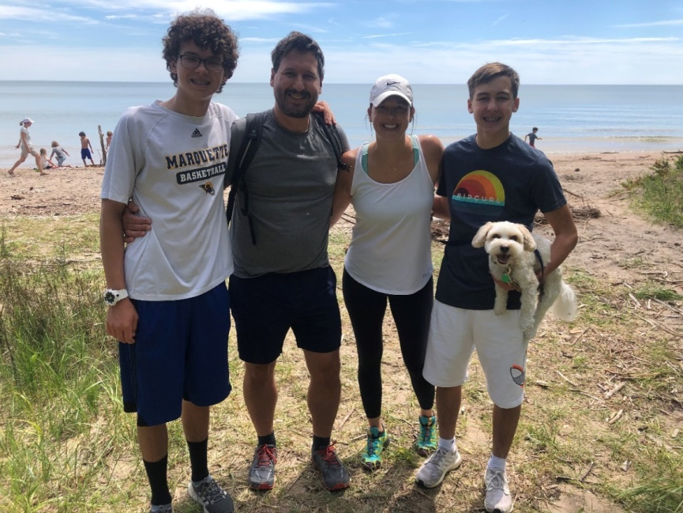

The family photo is from Harrington Beach State Park on beautiful Lake Michigan, one of our many COVID adventures to Wisconsin State Park.

We traveled to New Smyrna Beach every year from 2007-2014 to visit Julie's parents. Her parents were looking for a March getaway, did a ton of research, and fell in love with the Watermark--as did we. It was the first eight years of our kid's lives, and trips to NSB became some of our most favorite family vacations. In 2015, Julie's dad was diagnosed with ALS, and that ended everyone's trips to NSB. He passed away in 2017. After four years away from our happy place, we decided to make a return trip in December 2018. After our traditional mahi sandwich at Toni & Joe's, ice cream from Treats on the Beach, and a Jamaican Me Crazy iced coffee from Beachie Beans, we all looked at each other and said, "We belong here, let's find a place." The universe figured it out, and the rest is history.

Bill & Sandy
(#203)

November 18, 2020

Rental Group Newsletter

A November like no other

November rentals are running about 60% over the same month last year due in part to an unusually full house expected over Thanksgiving. While that is something Rental Group members can be thankful for, and a testament to the rental resiliency of the Watermark, we find ourselves this Thanksgiving focused less on how many will celebrate at our places and more on how safely… amid spikes, upticks & surges and, now, high hopes that a vaccination will soon allow us to return to the family get-togethers we cherish.

We've been warned for months about the shaky ground Americans will be on as we head into this Thanksgiving…how the safest thing we can do is to stay home and scale back traditional family gatherings... especially indoor ones where distancing is all but impossible, especially in gatherings of more than five or ten ... especially where folks will be shunning masks... especially involving anyone who hasn’t been tested recently or who hasn’t voluntarily self-quarantined in advance…especially if a college student is coming home to join in the festivities... and, most especially, if Memaw and Papa Bear will be emerging from hibernation to grace the occasion with their customary hugs, wisdom and utterly insane pecan pie.

By our count, that's an especially large number of especially's. Fortunately, the weather here has yet to freeze out the option of outdoor gatherings, so we can only trust the congregation will be taking full advantage of the safer harbor that the Watermark grounds and the beach offer.

Thanksgiving parking may well be limited. At such busy times, owners and their families know the drill: carpool as much as possible, and park in the garages to free up space to accommodate the overflow. The problem, says Donna, is that “We don't know how many owners will come and also how many guests an owner or a tenant will invite.” To be fair to all-- including our renters -- each unit will be allotted 2 passes -- one to the garage, the other for the lot. Nearest alternative? The park next door has parking for about 50.

One non-pandemic blessing we’ll be counting in 2020 is how it was that the Watermark just happened to survive (with only comparatively minor scrapes) the longest hurricane season on record with its 30 named storms. Seven owners have expressed an interest in upgrading their sliders before the 2021 season arrives in June. Several years ago, a dozen or so owners got an attractive group rate on heavier-duty, more wind-resistant sliders. If you haven’t already done so, let Kirk know if you want to add your name to the growing list of those seeking a quote.

We wish everyone a blessed and COVID-conscious Thanksgiving.

Bill & Sandy
(#203)

December 31, 2020
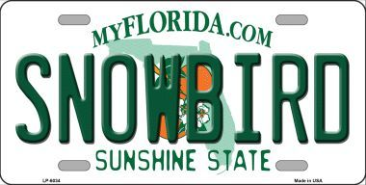
Rental Group Newsletter
Here come the snowbirds
At a time when many New Smyrna Beach condominiums are looking at significant vacancies due to the ongoing COVID crisis, the Watermark expects a full house of snowbirds this winter. Our 24 rentals were hit with cancellations, too – and still are hearing from snowbirds with health issues -- but thus far Donna & Kirk have had excellent results working the waiting list to find us replacement bookings for January thru April. As things stand, our flock will be migrating to the Watermark from 16 states: Michigan, Ohio, Wisconsin, Iowa, Minnesota, Illinois, Missouri, Pennsylvania, New York, Connecticut, Maine, New Hampshire, Rhode Island, Massachusetts, North Carolina and Georgia.
Scrubbed & sparkling
It’s said that nothing inspires housecleaning more than unexpected guests, but at the Watermark, nothing quite inspires a more nitty-gritty, down-and-dirty cleaning than guests we actually do expect. November’s higher than usual occupancy pushed most of our annual deep cleanings into December, and we’re happy to report that all that needed to be done by our in-house cleaning staff before the winter tenants are complete. We have 2 rental units that don't have Jan 1 tenants and will have theirs done in January.

2020 balance sheet
In spite of a 2-month shut down by Governor DeSantis and unprecedented waves of COVID cancellations, Watermark rentals ended this most difficult year with a modest loss in rental income of about 15% year over year.
Website traffic

Our website tallied 8,000 individual sessions in 2020… 4700 of which involved new users. The site’s biggest users were from Florida, Michigan, New York, Virginia and Indiana. There were 406 visitors in the past 28 days over the previous 28.

Picture this

We’ve begun to update exterior photos on the website to depict the repainted Watermark. After your winter renters have gone home, please plan to update any interior images that no longer depict your unit accurately due to renovations and décor makeovers. This can be arranged through the office at the very reasonable fee of $50 offered by the website host. Another way to help right now is to review the list of your unit’s amenities as shown on the site photos. Let Donna know of anything in that list needs to be revised.

Here’s to MMXXI
May your troubles be less and your blessings be more,
and nothing but happiness come through your door.

Bill & Sandy
#203

