June 11, 2021
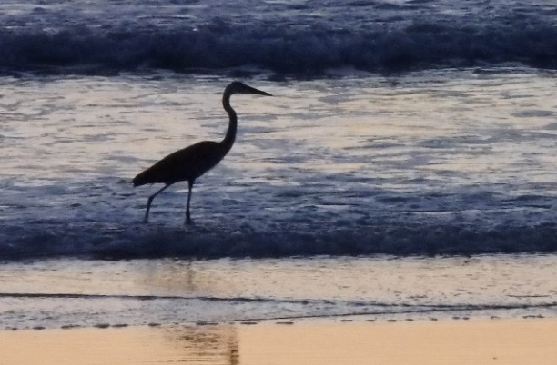
Rental Group Newsletter
Winter ’22 sold out All Watermark rental units for next winter have been spoken for. This says a lot about the bond we’ve established with our snowbirds, about the priority they give their annual pilgrimage and about the job D&K did this spring at renewal time.
Summer ’21 surging Donna tells us we’re 95% booked for summer, too. Of the 190 rental weeks available this season, 180 had been reserved by Memorial Day. NSB tourism overall appears to be coming back strong, well ahead of a year ago, according to city officials.

Hurricane Season Three units got coastal-grade sliders installed just ahead of hurricane season, bringing to 23 of 36 the total units with upgraded sliders. The sturdy look and feel of our Velocity-brand replacements will give Sandy & me peace of mind whenever a hurricane directly threatens the Watermark. Built to keep water out and drain it outside, this newer style slider will put an end to any need to line the tracks with rags prior to a hurricane. The only concern we’ve had thus far is with stepping over the 3½-inch threshold. It takes some practice – more for some than others -- so we’ve left a heads-up note for our renters.

Details, details We’ll be reviewing rates this fall but, meanwhile, we can’t stress enough how closely related is the job we do in keeping up with renter expectations. To that point:

- Donna says some throw rugs are looking dingy. [When replacing, get washable ones.]
- Some bedskirts are the same as they were when D&K started here five years ago. [If yours are frayed, stained or badly faded, replace as soon as you can.]
- Looks like the dirty walkway dilemma will be with us through peak summer rental season when heavier foot traffic will no doubt make the appearance even worse. For now, it’s most conspicuous at unit doorways on floors 2-6, at the elevator and steps of lower floor stairwells. Bill Biedenbach tells us the walkways are deep cleaned every couple of months and that those will continue, and reassures us the board is on the case.
- We encourage owners who’ve made renovations to update their website pics accordingly. It’s also an ideal time to members to review and update as needed the website text describing your rental unit’s amenities. Please contact Donna if you need to arrange a photo shoot or make a content change.

- Word’s out NSB, once among Florida best-kept secrets, has been getting some national pub: HGTV’s Top 20 beaches in Florida… Southern Living’s Salty Mermaid (as one of the favorite stays in the south) and Chicago Trib’s “Cutest beach towns in Florida.”

Around town The closest restaurant to the Watermark is eyeing a mid-to-late-June return after an unexpected kitchen fire this spring. Here is the link to a Hometown News article about how some patrons raised more than $20,000 in an effort to help the Beacon shine again:

tps://www.hometownnewsvolusia.com/news/customers-try-to-save-new-smyrna-beachside-eatery/a rticle_233da6e4-bcbf-11eb-b4c3-ef15d5c4b9c1.html

We invited our newest members to introduce themselves

We are Harold and Lisa Anness and reside in Cincinnati, Ohio. We were fortunate to close on Unit 604 on February 19, 2021 after working on the deal for almost a year. We originally purchased a unit at Holiday Cove North in 2006. Harold retired as a real estate attorney in 2018 and we started spending more time in New Smyrna Beach.

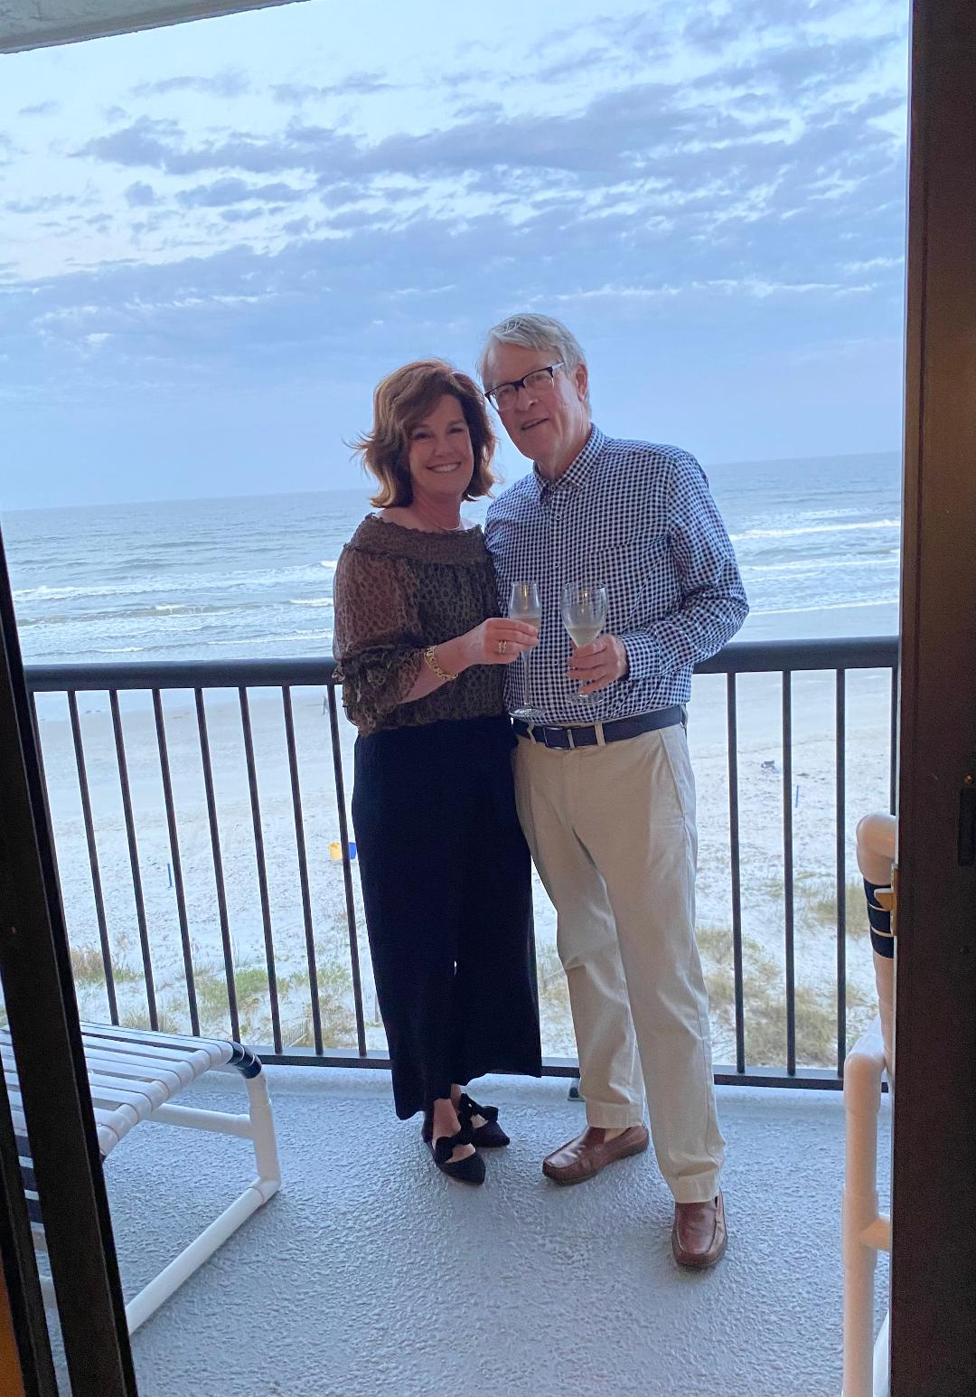

We soon realized that more space was needed which put the Watermark in play. Lisa is an international Delta flight attendant based in New York. Lisa took a 13-month time-out because of COVID-19 but started back to work on May 1st with a trip to Tel Aviv. We spent last winter at the Watermark in Unit 603. Hopefully our renovation of Unit 604 will start shortly after Labor Day and be completed by year’s end. We intend to spend the winter in New Smyrna Beach. We look forward to meeting everyone.
Bill & Sandy (#203)

