March 15, 2021
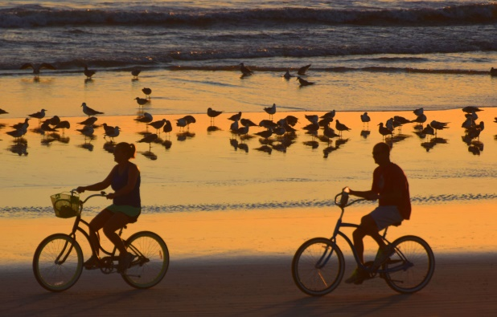
Rental Group Newsletter
Summer outlook
This week is the first anniversary of when most of us heard about the global pandemic, and were advised to stay in, space out, lay low, mask up, order out, stop shaking hands and start washing them. We stocked up on Lysol, Clorox Wipes, Purell and toilet paper if we could find them. The phones at the Watermark started ringing and ringing with people canceling vacations. Over the past year we changed the way we live, and most of those changes – like the Plexiglas partition in the manager’s office -- are still part of the daily routine. The COVID virus has claimed more than 2 million lives worldwide. It is still with us, and it has now sprouted variants. But we know a lot more about this enemy than we did at the start, and now have an arsenal of effective vaccines that we didn’t have a year ago. Finally, this world war seems winnable. The phones are still ringing again at the Watermark, but this time they’re different. “One day around the first of the month, we took eight reservations in one day!” Donna told us.
- April is sold out.
- May is completely booked.
- June is filling in nicely.
- July is mostly full, with a handful of openings in the latter part of the month.
- As far out as the first week of August (7/31-8/7) only 3 units are un-booked.

Website enhancements
The redesigned website turns 4 this month. We’re working with Shea & Elisa over at Hosting NSB on freshening up the welcome-page slide show. Check it out.

Snowbird status
Our winter renters have settled in -- a friendly bunch, relieved and grateful to be in Florida… swapping strategies on how and where to get COVID vaccines. To that end, they’re getting with some assistance from Donna and Kirk with the paperwork they need to verify short-term residency.
Beach driving

Mark Lane, columnist for the Daytona Beach News Journal has been covering the beach driving issue since the Model T. His take on the controversy heating up again: “Without beach driving, large stretches would be inaccessible to locals or tourists. But opening to driving everywhere would mean tearing up painstakingly negotiated agreements with the U.S. Fish and Wildlife Service that limit driving to protect sea turtles and other wildlife. Meanwhile, sea-level rise and beach erosion are steadily at work closing big swaths of beach to cars regardless of anything the county decides. Nature favors a long-range traffic phase-out. Fortunately, this is a big beach — 47 miles [in Volusia County] — with room for driving in some places and traffic-free stretches in others. The current compromise is an uneasy one but accommodates all beachgoers. And it will remain that way even though the argument is once more getting heated.”

Where lives pass, memories carry on forever.
It was with much sadness that we learned of the passing of Jim Weeks (#401) and Beverly Fleming (#201), two longtime owners whose good natures helped make the Watermark community such a special place over the years. Our hearts go out to Sue and the Weeks family, and to the Flemings and Boones on their loss. Here are the links to the obituaries:
JAMES WEEKS Obituary (2021) - Lakeland, Fl, FL - The Ledger (legacy.com)
Beverly Fleming Obituary (2021) - Orlando, FL - Orlando Sentinel (legacy.com)

Bill & Sandy (#203)

