August 5, 2021
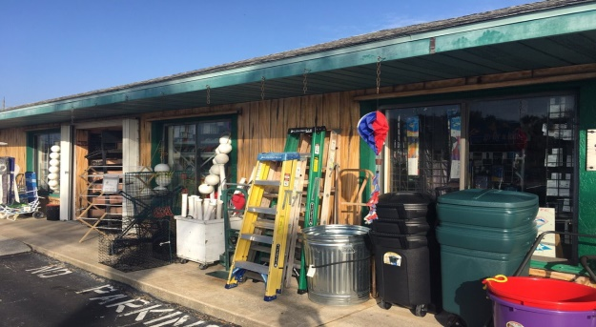
Rental Group Newsletter
Venerable beachside hardware store is closing
Some got keys made there…others found their odd-size a/c filters; their beach carts, funky kites, metal detectors, tide clocks and frozen bait. For four decades, Coronado Hardware, just a mile south of the Watermark, has been a lifesaver to beachside residents as the closest source for all variety of whatsits, thingamajigs and doohickeys. We sorely miss this small place already, just hearing it will close soon following the owner’s retirement. We wish all those folks well.
Back in business? Volusia’s bed tax collections were up 517% in April from the paltry level a year ago… and up 121% from May 2020. At the Watermark, Donna reports September & October bookings are looking “pretty full” but notes that she got a few cancellations last week due to Florida’s high COVID numbers.
Red Tide blues A growing algae bloom on the state’s west coast once again is threatening summer tourism along several of Florida’s premier beaches. In Pinellas County alone (St. Pete, Clearwater.), three million pounds of dead fish were removed last week. Last time it got that bad (2018), many vacationers scrambled to find lodging along the state’s East Coast where Red Tide is less frequent. Since the early 1950s, the Red Tide has struck the Gulf coast nearly 60 times, and the Atlantic coast only nine.

Preventative maintenance With our a/c condensers up on the roof, the beating they take from the harsh coastal elements is out of sight, and often out of mind. That’s why an annual lookover is prudent. Owners once had an opportunity to have this done at the same time by the folks that service all but one of the Watermark’s a/c’s (Advanced Air, 386-675-1158) at a minimal cost per owner. The group aspect of that deal is no longer offered but the rest of service is, the same 18-point visual check for same low cost ($18.95). A more thorough 66-point service call runs $79.

Leland Warmoth The Watermark lost another old friend with the passing of Leland Warmoth, husband of former rental agent Joan. As Joan’s right-hand man, he helped owners and renters with their fix-it needs. A proud Navy vet, he was the longtime GM of a Volkswagen dealership in Illinois before coming to NSB to be near his grandchildren (now numbering 11). An avid boater and golfer with three holes-in-one to his credit, he loved being near the coast. He lived his life with his favorite motto in mind: “You have to make your fun; it doesn’t just happen.” He was 89.

Sea-worthy

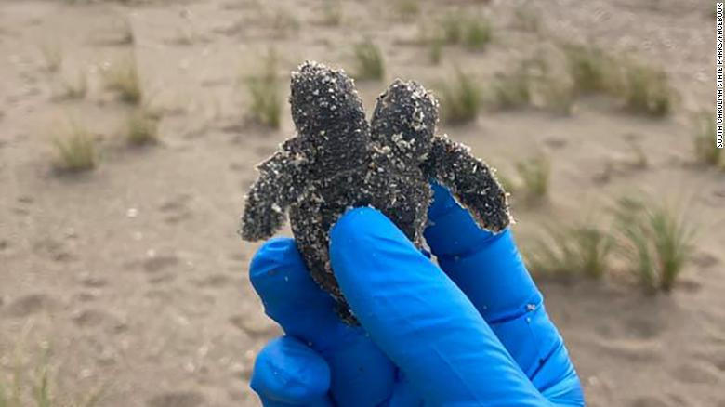
South Carolina State Parks
This two-headed baby sea turtle was one of five hatchlings discovered in a nest found on a South Carolina beach, at Edisto State Park, last week. A group of turtle nest patrollers were making a routine check when they stumbled across the rare loggerhead. Nesting season runs May through October.
Bill & Sandy
(#203)

