May 25, 2022

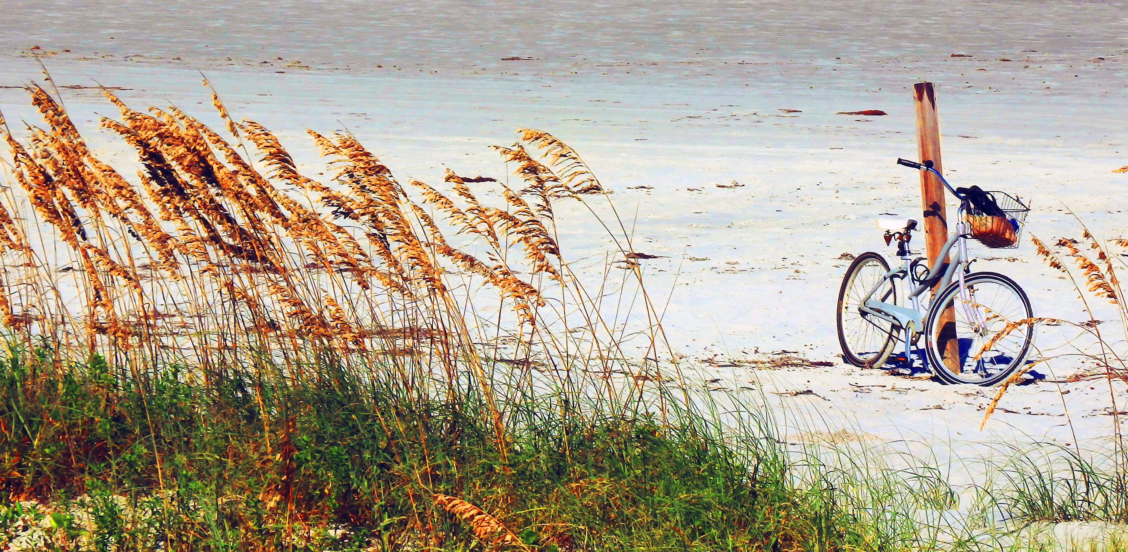

Rental Group Newsletter
Just in: In special session, the Florida legislature has provided some direction on condo safety reform after the two chambers failed to reach a compromise earlier this year. Under newly filed legislation [that needs passage in both House and Senate] condo associations wouldn’t be allowed to waive reserve funding after Dec. 31, 2024… condo buildings three stories tall and higher would be inspected when they reach 30 years old, and every 10 years after that… and buildings near a coastline would need to be inspected at 25 years of age and re-inspected every 10 years.
Winter ’23 outlook: Sunny & bright We hear from Donna that snowbird renewals went extremely well this Spring – so much so that we’re only one rental week (in late April) shy of a sellout next winter. There’s this reassuring tidbit, too: Our snowbirds showed little resistance to the 6% rate increase that’ll kick in for them next winter.

Summer ’22 short of a sellout
With two fewer owners renting out their places this summer, the Watermark’s peak summer season of June, July and the first half of August is 14 rental weeks short of a sellout. The breakdown: There are four rental weeks available in June, six left in July and four remaining in the first half of August.

Around town Beginning this month thru late Fall, the North Causeway Bridge (SR44) will be closed intermittently for some underwater electrical upgrades. When necessary, traffic will be detoured to the South Causeway Bridge. For same-day info, please check FDOT’s website www.cflroads.com

NSB among South’s best beach towns NSB cracked Southern Living’s 2022 list of the South’s Top 20 Beach Towns at #15. Hilton Head Island was #1. Florida towns dominated rankings -- Key West, St. Augustine, Panama City Beach, Pensacola Beach, Grayton Beach, Sarasota and Captiva all coming in ahead of NSB @ #15. “Surf, sand and salt air top the list of must haves,” noted the editors, “but our favorite destinations have something more – authentic character.”

Hurricane pre-season For seven straight years, hurricanes have come before the official June 1 start of Hurricane Season. Best bet: Prepare to prepare.

Helping sea turtles see Nesting season started May 1 with the loggerheads becoming more active along our coast. Last year 377 loggerhead nests were identified along Volusia beaches north of the inlet and about as many south of it. Through Oct. 31, all indoor and outdoor lights visible from the beach must be shielded, repositioned, replaced with special turtle-friendly amber bulbs or turned off after dark.

3 cool summerizing tips Keep all a/c vents wide open to optimize air flow and minimize mildew… make sure your ceiling fans are rotating counter-clockwise to optimize downward circulation in the summertime…have some fans around just in case it’s your unit’s a/c that conks out this summer and can’t be quickly fixed. There are many table models that swivel and tower models in the $50-$100 range that are stylish, quiet, remote-controlled and portable. Some have luggage-type rolling wheels.

Sea-worthy When we stoop to admire a seashell we hardly expect to see a kind, curious face of a Disney movie character looking back at us. That’s what happens somewhat regularly with serious shell collectors.

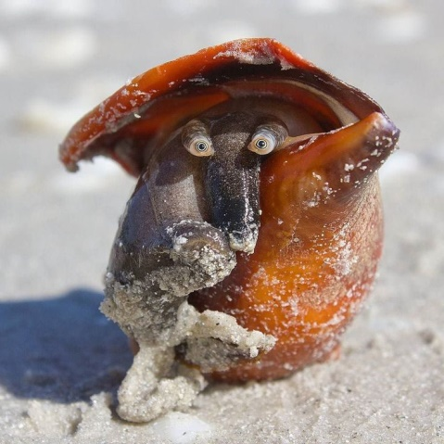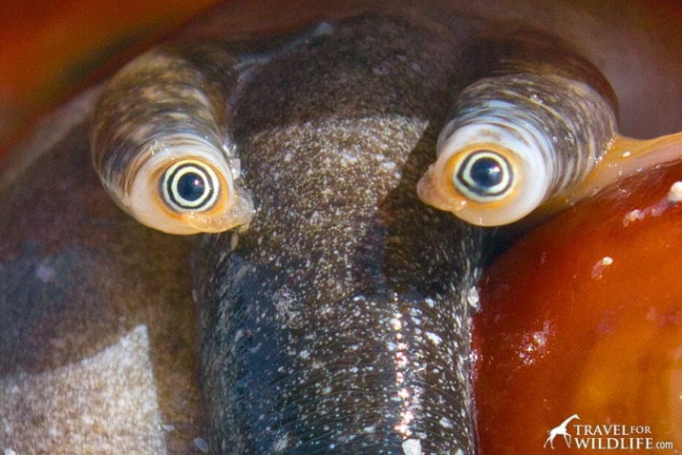
This little guy was among the hundreds of Florida Fighting Conch stranded on Sanibel not too long ago. Don’t let the name fool you -- Florida Fighting Conch aren’t combative. In fact, they’re peaceful carnivores that do very well as aquarium pets.
Bill & Sandy [#203]

