July 2, 2022
Rental Group Newsletter
First impressions We like the look and feel of the new entrance sign just approved by the Watermark board. Contemporary and eye-catching, the monument-style is new for the Watermark but a popular look among larger NSB condos with whom we compete for vacation rentals… A welcomed upgrade because it promises to raise the Watermark brand’s profile in the local vacation rental market…also, because the old sign was on life support, as one board member so aptly put it. The design emerged from several considered by a board-appointed team led by Beth Corso (#101) working in collaboration with Nick Floria of Coastline Wholesale Signs, Daytona Beach. Look for it to be up -- lighted and landscaped -- by September.
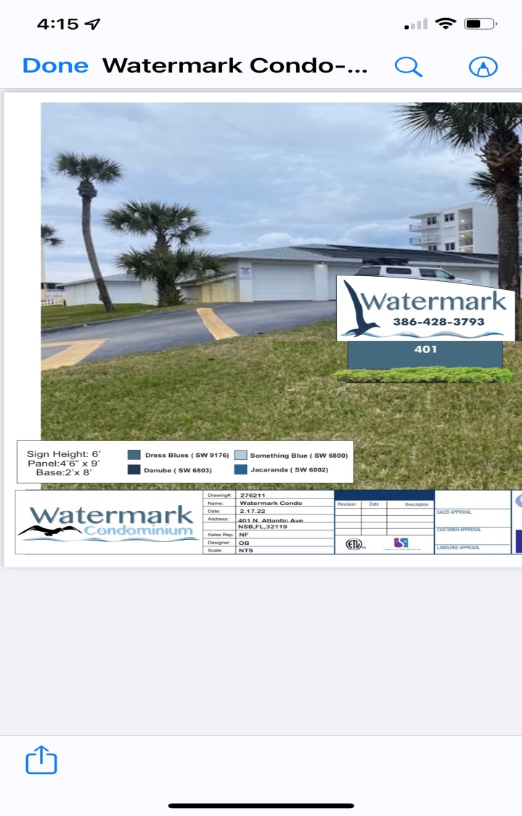
Something to celebrate We hear from Donna that neither gas prices nor the economy have caused any pullback on Watermark rentals. Instead, she’s been seeing lots of tenants renewing a full year ahead … and lots of outside requests, too, for rentals next May, June, July. Demand for June and July is not surprising. That May 2023 is nearly booked a full year out is something we haven’t seen before.
No longer renting At one time or another you may have toyed with the idea of downsizing and moving to New Smyrna. Jim & Nancy Greene are beyond the toying stage. They’re decision is final. They’ll no longer be renting out the lovely place (#303) they acquired from Jim’s aunt in 2014. They’re moving to the Watermark for good. This brings to five the number of units occupied by permanent residents…and to 22, the units that are rented out at least part of the year.

See-worthy
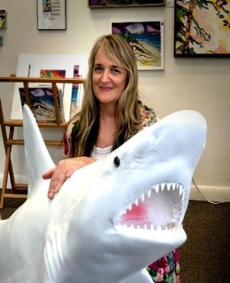
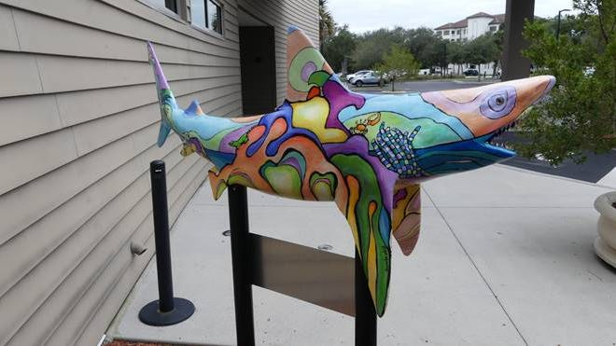

It’s no secret NSB is the shark bite capital of something or other. So why not just embrace it? That idea, floated a couple of years ago by a NSB youth group, actually got some traction, and today has become a reality in the form of decorative shark statues placed around town. The funky one shown here with its creator Eliza Midgett is located at the Brannon Center, 105 S. Riverside Drive. Other locations: Alonzo “Babe” James Community Center, 201 N. Myrtle Ave. , City Marina, 201 N. Riverside Drive, Development Services Building, 214 Sams Ave., Live Oak Cultural Center, 1050 Live Oak St. Volusia County had the highest number of recorded shark bites in Florida last year, with 17 incidents (none fatal) tracked by the International Shark Attack File.
Bill &Sandy (#203)

