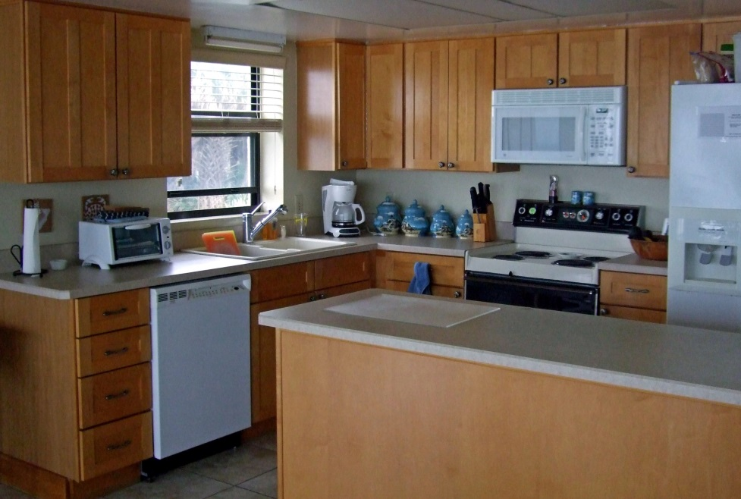

**Minimum requirements for rental units**

**Cleaning supplies**

broom

mop

mop bucket

dustpan

vacuum cleaner (w. attachments)

& supply of extra bags

extra specialty light bulbs

extra a/c filters

clean front door mat

**Cookware**

one-quart saucepan

one-and-a-half-quart saucepan

two-quart saucepan

8-inch non-stick skillet

10-inch skillet with lid

roasting pan

soup pot

baking pan

cookie sheet

2 casserole dishes

**Glassware (matching)**

8 6-ounce tumblers

8 8-ounce (or larger) tumblers

8 wine glasses

salt & pepper shakers

**Tableware**

8 place settings of microwave-safe dishes

8 place settings of stainless-steel flatware

2 serving spoons

salad bowl set

3 serving dishes

8 coffee cups/mugs

**Cutlery**

6-inch serrated knife

8-inch serrated knife

butcher knife

carving knife

paring knife

8 steak knives

cook’s scissors

**Small appliances**

microwave oven

in-sink garbage disposal

[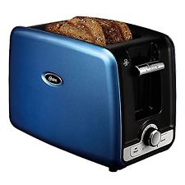](http://www.ebay.com/itm/Oster-2-slice-Retractable-Cord-Toaster-Metallic-Blue-/172410172023?hash=item2824727277:g:LfkAAOSwux5YK4q~)

toaster (or toaster oven)

electric hand mixer

blender

automatic coffee maker

**Misc. kitchen equipment**

cooking fork

metal pancake turner

Teflon pancake turner

bottle opener

can opener

**[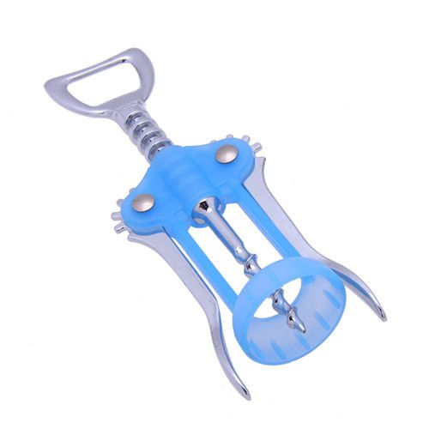](https://www.pinterest.com/pin/224757837631416468/)**Learn more at casilmarketing.com

wine opener (corkscrew)

set of measuring cups

set measuring spoons

wooden spoons

cutting board

2 rubber spatulas

kitchen area rug

waste can with lid

potato peeler

juice container

colander

set of mixing bowls (3 sizes)

grater

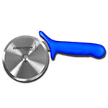

pizza cutter

ice cream scooper

a few basic office supplies (notepad, pen, scissors, tape, paper clips or extra batteries)

Fire extinguisher for under the sink

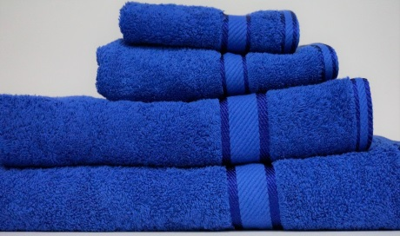

**Bath**

12 bath towels

8 hand towels and wash cloths

1 throw rug for each bath

**Linens**

6 dish towels

6 dish cloths

4 pot holders

**Bedroom / Sleeping**

king or queen bed in master

2 twins, king or queen in guest BR

2 sets of linens for each bed & sofa bed

clean pillows w. covers for beds & sofa bed

1 bedspread/comforter per bed

mattress cover for sofa bed (at minimum)

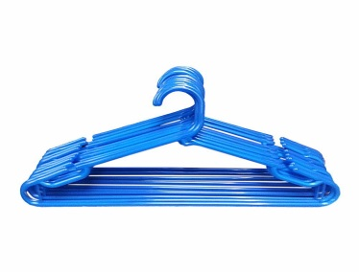

ample plastic hangers in each closet

1 waste basket per bedroom

smoke alarm in each BR

**Living room**

TV with basic cable service

closable ocean-side blinds/curtains

**Utility room, etc.**

flashlight or battery-operated lantern or battery-operated candles

step stool

plunger

**Optional Suggestions**

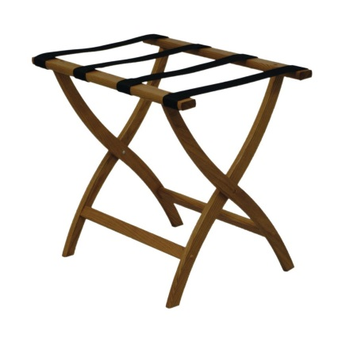

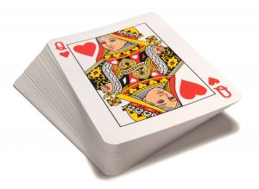

* first-aid kit
* suitcase valet
* computer desk
* makeup mirror
* beach towels
* sleeper sofa
* rollaway
* tv instructions
* tv trays
* board games
* playing cards
* extra pillows
* guest book
* Florida map